Guide to Mistos

# Scope

Mistos is a **M**icroscopy **I**mage **St**orage and **O**perating **S**ystem with the purpose to standardize image storage and evaluation. Its’ features include:

* Import and store images in the integrated database
* Evaluate images individually using
  + Manual image segmentation
  + Semi-automated segmentation
  + Fully automated segmentation utilizing Deepflash (Cuda ready GPU’s only)
* Estimate a ground truth segmentation by processing multiple experts’ segmentations
* Create and store experiments
* Export
  + Raw Images
  + Experiments, you may export
    - Images
    - Binary label masks
    - Images and binary label masks cropped or padded to match a specified image size

Please refer to the readme in the main Mistos folder for details about the setup, troubleshooting, or technical details. If questions arise or issues occur, please submit them on our github page (<https://github.com/Maddonix/mistos_2>).

# Getting started

After installation, start Mistos by running the “start_mistos.bat” script. Three command lines will be opened:

1. Mistos Frontend
2. Mistos Backend
3. Mistos Fileserver

After the system is initialized, you can access it from your Internet browser by calling the address “<http://localhost:4200>” (if you receive a 404 error try typing just “localhost:4200”).

The following Demo Experiments will show you how to use Mistos. Since later demo experiments use files created in previous examples, pleas perform experiments in the right order.

# Principles of Mistos

Mistos works with a standardized format and evaluation method. Therefore, there is a list of guidelines. If followed you will achieve good results with Mistos, and be able to standardize your own workflow.

1. If you want to measure the intensity of your images, make sure to add a background layer. Only use the label 1 in this mask. Make sure, that all channels are just background signal in the marked area.
2. If you work on a Z-Stack, keep in mind that you may label all slices individually or label them at once by checking “n-dim” in the left toolbar (only visible if a label layer is selected)
3. Functions in the Napari viewer will always use the selected layer on the left side if there is no possibility to choose.
4. Don’t choose multiple layers in the Napari viewer at once. This will produce unwanted behaviour.
5. We always measure one image modality (e.g. nuclei) at a time. For this, we create a label mask and use a different label for each entity (this means: first nucleus has label 1, the second 2, …). If we want to measure two different entities in an image use different experiments or at least different experiment groups.
6. While Napari Viewer is opened, you can not work with the browser app.

# Navigation

## Dashboard

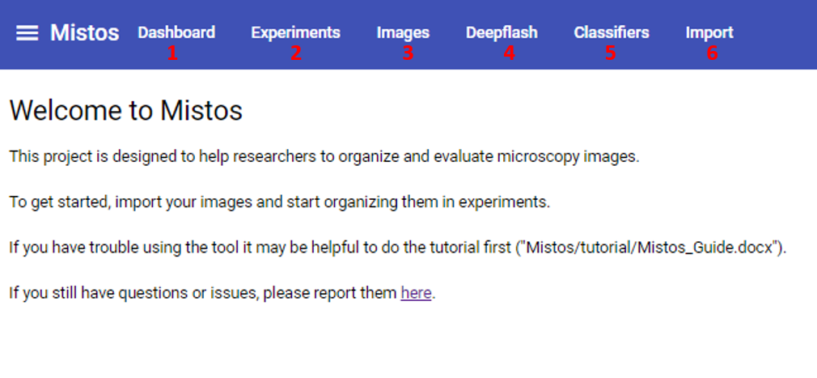

Figure 1. Dashboard

If you open Mistos in your browser, you will start here.

**1 Dashboard:** Takes you back to this screen.  
**2 Experiments:** Takes you to the experiment organizer.  
**3 Images:** Takes you to the image organizer.  
**4 Deepflash:** Here, you may estimate the ground truth for an image from multiple annotators labels and use Deepflash models to predict the labels for an image.  
**5 Classifiers:** Here, you may organize your imported Deepflash models.  
**6 Import:** Takes you to the importer. Here you may import images, Mistos export files, and Deepflash models.

## Import

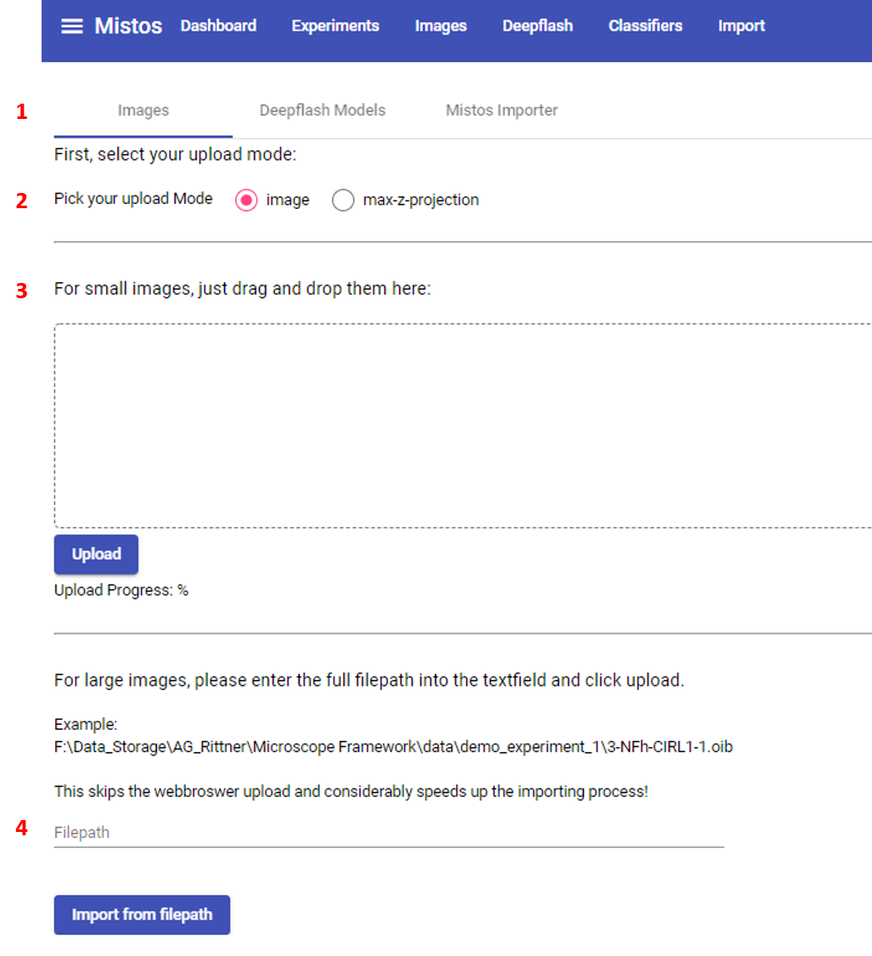

Figure 2. Image Import Screen. After you click on Images in the top navigation bar, you start here.

**1 Choose Importer:** Click on the type of file you want to import.  
**2 Upload Mode:** Takes you to the experiment organizer.  
**3 File Upload:** Drag and drop one or multiple files into the box and click upload to import your files. Currently this is not recommended for files larger than 200 mb, as these images will take a long time to import.  
**4 Import file from path:** Copy and paste the path to your image (e.g., “C:\Users\franz_herbert\desktop\example.tiff”) here to import your file. This is recommended for large files, as it will be considerably faster.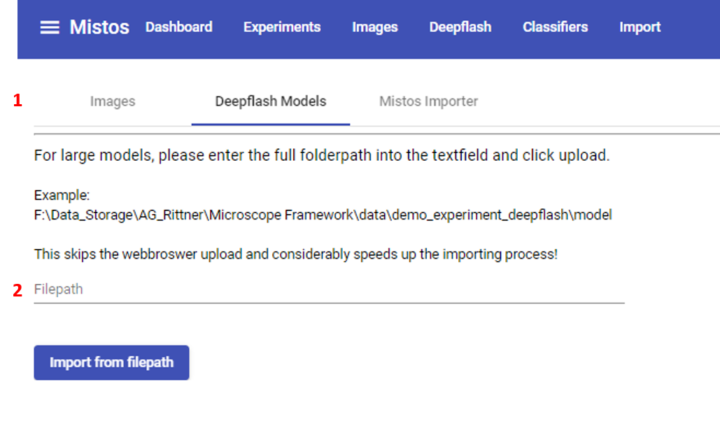

Figure 3.Deepflash Model Importer Screen. A click on “Deepflash Models” in any importer screen will take you here.

**1 Choose Importer:** Click on the type of file you want to import.  
**2 File Upload:** Copy and paste the path to your model folder which may contain a single model or an ensemble of models (e.g., “C:\Users\franz_herbert\desktop\my_model”) here to import your model.

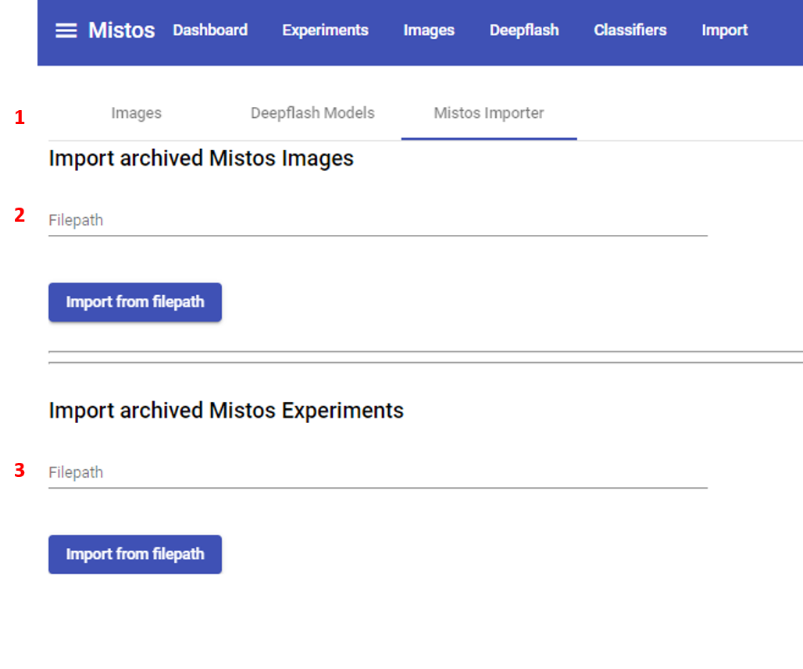

Figure 4. Mistos File Importer Screen. A click on “Mistos Importer” in any importer screen will take you here.

**1 Choose Importer:** Click on the type of file you want to import.  
**2 File Upload - Image:** Copy and paste the path to your archived image (e.g., “C:\Users\franz_herbert\desktop\archived_mistos_image.pkl”) here to import your image. It will contain the image as well as all annotations and measurements associated with it when exported.   
**3 File Upload -Experiment:** Copy and paste the path to your archived experiment (e.g., “C:\Users\franz_herbert\desktop\archived_mistos_image.pkl”) here to import your image. It will contain all images and groups, as well as all annotations and measurements associated with it when exported.

## Images

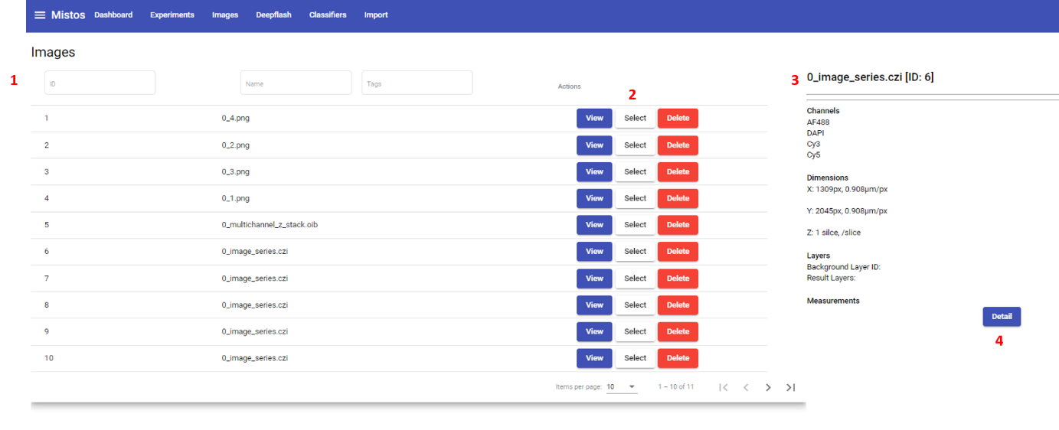

Figure 5. Image List. A Click on “Images” in the top navigation bar will take you here.

**1 Image Table:** A list of images, you can filter and sort by name, id, and tag. Furthermore, you may change the number of displayed items in the bottom section of the list.  
**2 Image Controls:** *View:* A click opens this image in the image viewer. *Select:* A click opens this images preview section on the right side. *Delete:* Opens a dialogue where you may delete the image  
**3 Image Preview Section:** Brief summary of the image (Channels, Dimensions, Existing Annotation Layers).

**4 Image Detail Button:** Takes you to the image Detail page. 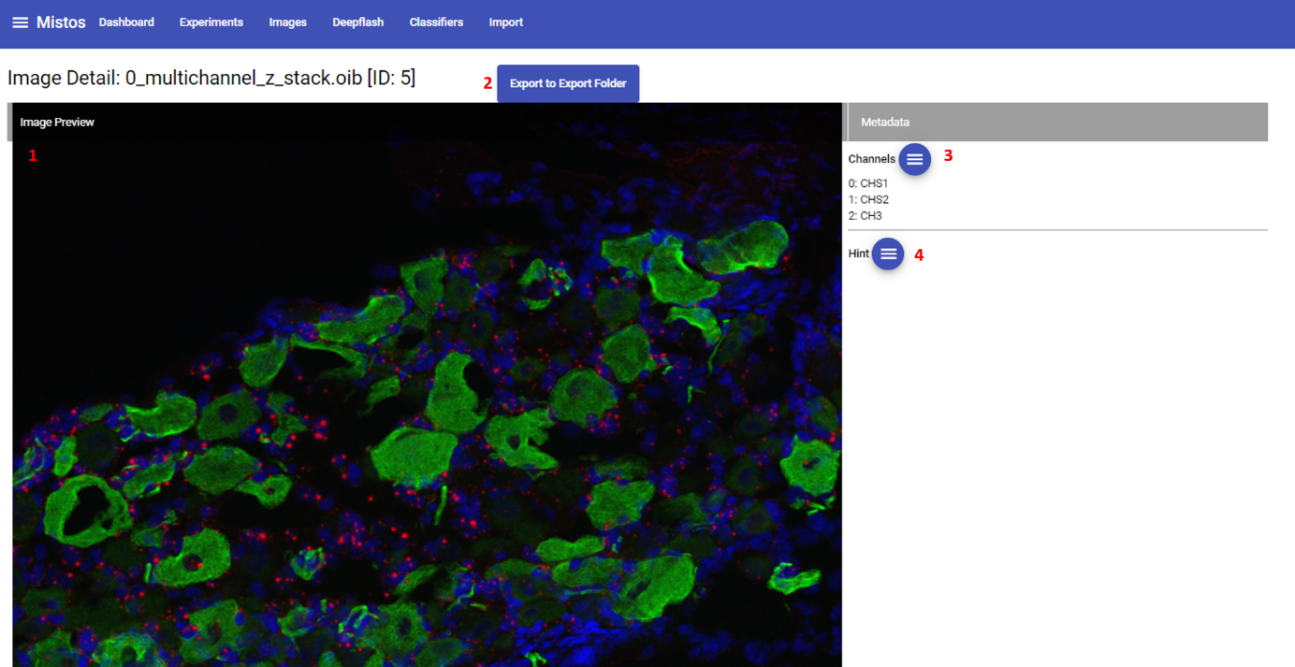

Figure 6. Image Detail, Top Section. A Click on the “Detail” Button in the image preview section of the image list screen takes you here.

**1 Preview of the Image:** Preview contains only first three channels.  
**2 Export as Mistos Image Button:** Exports the image as Mistos format image to the export folder.**3 Channel Names:** Channel names can be edited by clicking on the button.

**4 Hint:** Notes regarding the image.

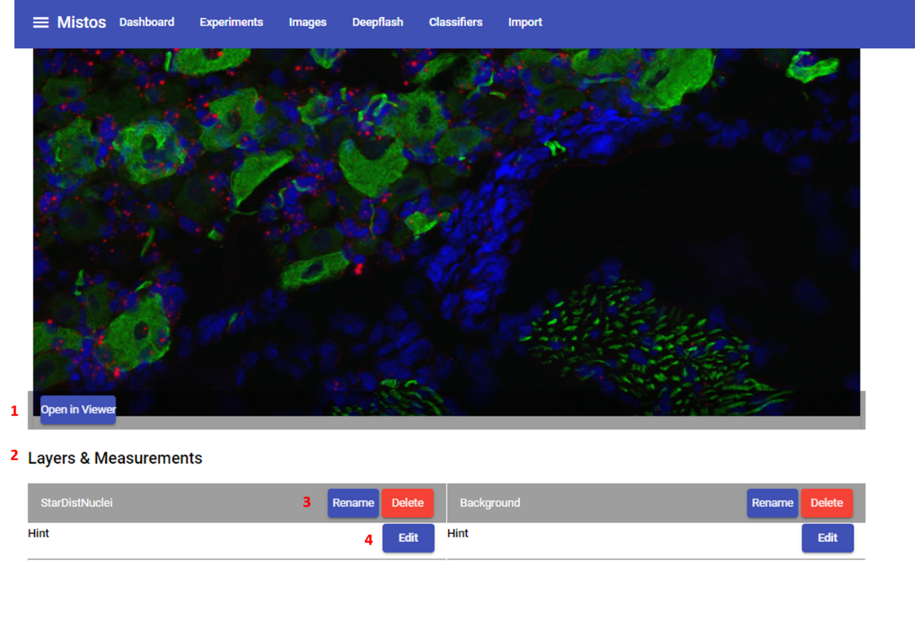

Figure 7. Image Detail, Bottom Section.

**1 Open Image Button:** Opens Image  
**2 Layers and Measurements Section:** Contains info for all annotations of this image.**3 Rename & Delete:** Rename or delete an annotation layer.

**4 Hint:** Notes regarding the annotation layer.

## Experiments

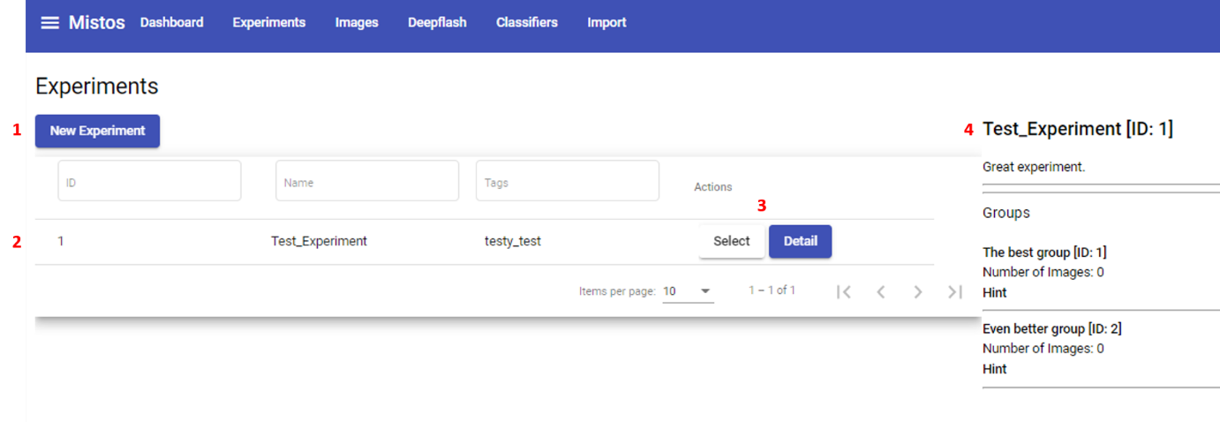

Figure 8. Experiment List. A click on “Experiments” in the top navigation bar will take you here.

**1 New Experiment Button:** Opens the “Create New Experiment” dialogue.

**2 Experiment Table:** A list of experiments, you can filter and sort by name, id, and tag. Furthermore, you may change the number of displayed items in the bottom section of the list.  
**3 Experiment Controls:** *Select:* A click opens this experiment’s preview section on the right side. *Detail:* Opens The experiment’s detail page.

**4 Experiment preview section:** Brief summary of the experiment.

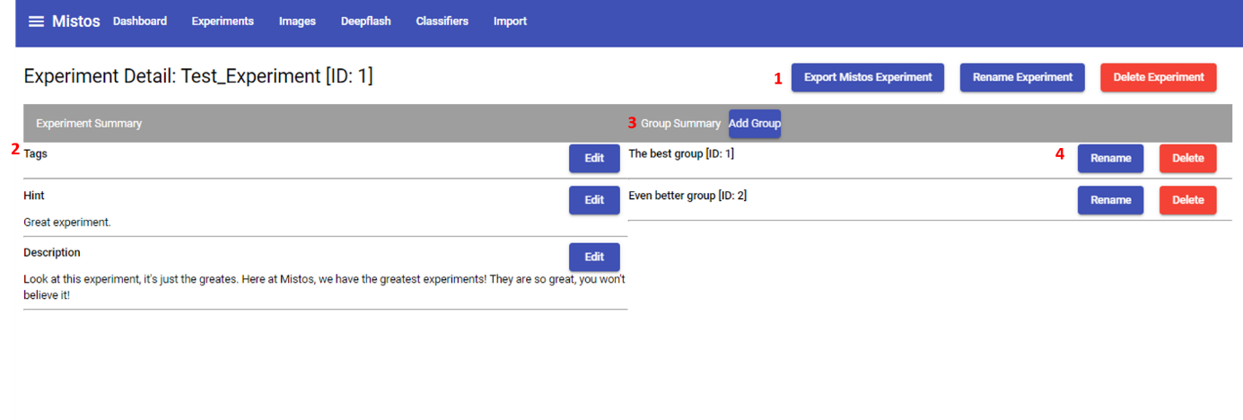

Figure 9. Experiment Detail, Top Section

**1 Experiment Controls:** *Export Mistos**Experiment:* Exports the Experiment with all images, groups, and annotations in Mistos format. *Rename Experiment*: Change the experiment’s name. *Delete Experiment:* Opens delete experiment button.

**2 Experiment details:** Tags, Hint, and description of the Experiment.  
**3 Add Groups:** Add experiment groups.

**4 Group Controls:** Rename and delete experiment groups.

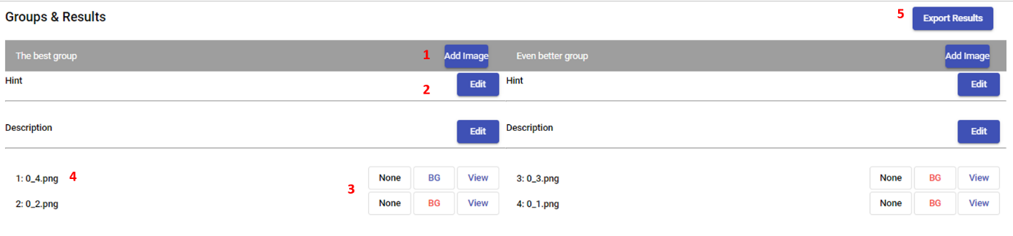

Figure 10. Experiment Detail, Bottom Section.

**1 Add Image:** Add an image to the group.

**2 Group details:** Hint and Description of the experiment group.  
**3 Images:** Details of the added images. With a click on the box saying “None”, the label layer may be selected. “BG” indicates if a background layer has been annotated for this image (red, no background; blue, background annotated; currently needs refresh of the page if you opened a viewer from here and added a background layer). A click on “View” opens the image in the image viewer.

**4 Image Name:** Name of the added image, click here to open a dialogue to delete an image.  
**5 Export Results:** Opens a dialogue to export an experiment:

* Include Images: Images will be exported as tiffs
* Include Masks: Masks will be exported as tiffs.
* Include rescaled Images and Masks: Masks and Images will additionally be exported and cropped or padded to the given x and y dimensions.
* Export Masks as Rois: each individual label of a mask will be exported as “.roi” file. To easily import them into software like ImageJ you can compress all .rois to a .zip file. *Only check this box if your labels can be represented as a polygon!*
* Export Masks as .png: Masks will be exported as .png files instead of .tiff files (important to use them for DeepFlash training)
* Export Masks as binary masks: Masks will be exported as “black or white” masks, if not checked, each individual label will have its on integer value.
* Channel to export: if -1 is selected, all channels will be exported. If input is 0 or larger, only the selected channel will be exported. *Channel count starts at 0! Input must not be larger than number of channels*

## Classifiers

A click on Classifiers takes you to a similar list as for images and experiments.

## Deepflash

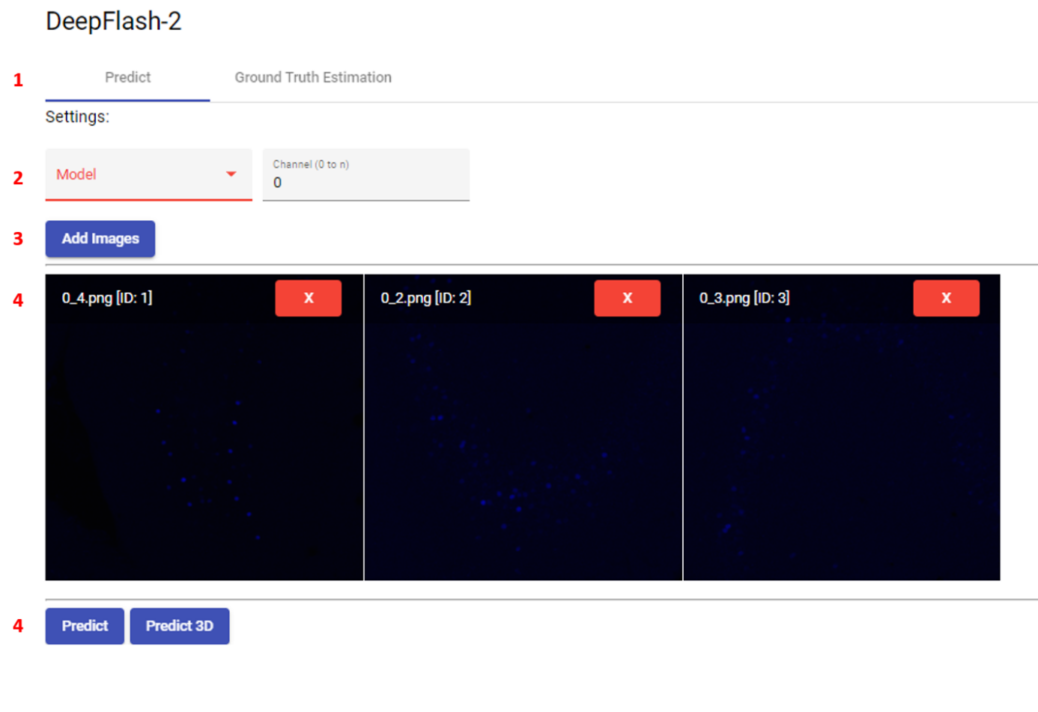

Figure 11.DeepFlash, Predict. A click on Deepflash in the top navigation bar takes you here.

**1 Navigation:** Choose between image prediction and ground truth estimation.

**2 Selection:** Select Model and which channel should be used for prediction. Channel count starts at 0, channel number must not be larger than the number of channels of the images.  
**3 Add Images:** Opens a dialogue to add images to the prediction list

**4 Image Preview:** Preview of the selected images. A click on the red “X” button removes the image from the list  
**5 Predict: “**Predict” will transform all images to max-z-projections before prediction if they have more than one z-slice. “Predict 3D” is currently not supported by DeepFlash. As a workaround, each z-slice will be predicted individually, and the results will be merged to a z-stack again. Result will be added to each image as label layer.

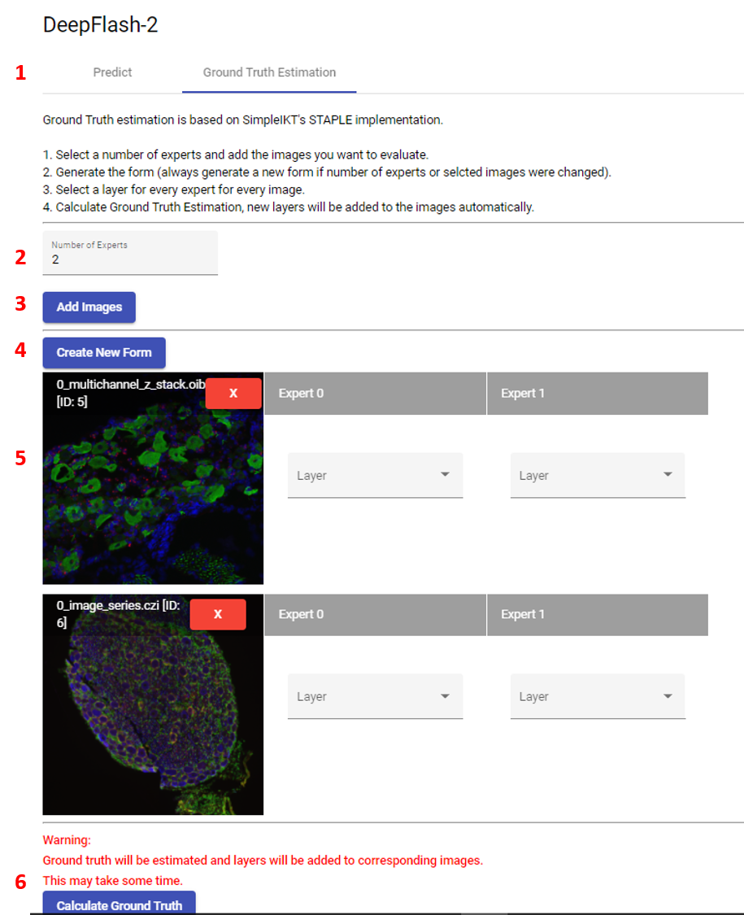

Figure 12. Ground Truth Estimation.

**1 Navigation:** Choose between image prediction and ground truth estimation.

**2 Selection:** Select the number of experts.  
**3 Add Images:** Opens a dialogue to add images to the list  
**4 Create New Form:** A click on this button will add / update the input fields for the expert annotations.

**5 Image Preview:** Preview of the selected images. A click on the red “X” button removes the image from the list. Each expert’s input must be filled with a layer.  
**6 Calculate Ground Truth:** Ground truth will be estimated with SimpleITK’s STAPLE algorithm implementation. Result will be added to each image as label layer.

## Napari Viewer

Shortcuts while in labelling mode:

* Alt: Erase mode
* Ctrl: Fill mode
* Space: Move even if pan/zoom mode is not active
* P: Paint Mode
* L: Pick Mode (click on label to select colour)
* M: Select next free label number
* Ctrl + N: Select and zoom to next label
* Ctrl + B: Select and zoom to previous label
* Ctrl + D: Delete the selected label
* Ctrl + E: Expand selected label by one pixel row
* Ctrl + R: Reduce selected label by one pixel row

If general questions for the handling of Napari viewer arise, please refer to the official Napari tutorials: <https://napari.org/tutorials/fundamentals/viewer.html>

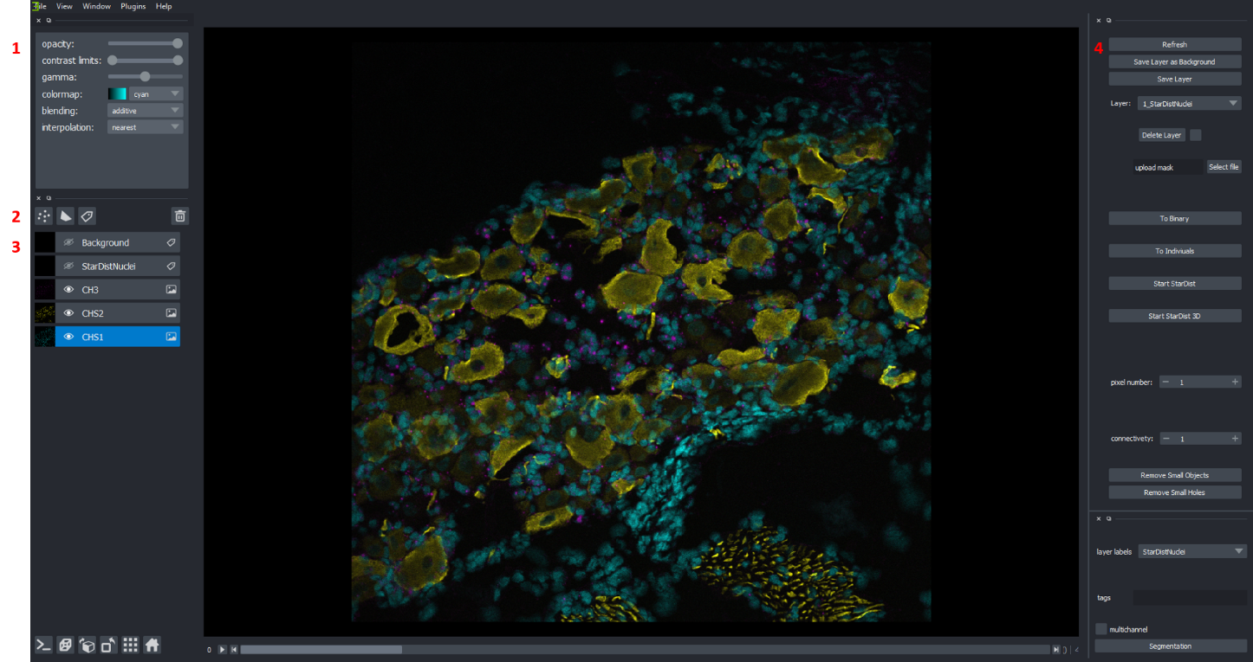

Figure 13.Napari Viewer Overview

**1 Layer Settings:** Changes between label and image mode, depending on selected layer. Basic functionalities like drawing, panning, zooming, colormapping, blending, contrast and opacity may be changed here

**2 New Layers:** From left to right: Points, Shapes, Labels. Currently *only label layers* are supported. Every other layer will cause errors if saved to database.  
**3 Layer List:** List of all Layers. Click on the eye hides/shows the layer. Click on the name enables name editing (*only edit the name before saving a layer, otherwise it will have no effect!*). The blue layer is currently selected. Most actions in the right-hand menu, assume, that you want them to be performed on the blue layer. *Only select one layer at a time if you perform a action from the right-hand menu*!  
**4 Right-Hand-Menu:** Mistos specific functions:

* Refresh: Refreshes image from the database
* Save Layer as Background: The selected layer will be saved to the image as background layer.
* Save Layer: The selected Layer will be saved to the database
* Delete Layer: The layer selected in the dropdown menu will be deleted, only works if checkbox is checked (safety first!)
* Upload mask: Select .roi, .zip (with rois), or .tiff mask and import it as layer.
* To Binary: Selected label layer will be turned to a binary mask
* To individuals: Selected label layer will be turned to a label layer with an individual label for all pixel clusters not touching.
* Start StarDist: Selected Image channel will be processed to a max z projection and nuclei will be predicted.
* Start StarDist3D: Selected Image channel will be processed as z-stack and nuclei will be predicted.
* Remove small objects / holes: small pixel clusters or small holes within labels will be removed from the selected label layer. Small is defined as smaller than the defined pixel number with a distance to the next cluster / hole defined by connectivity.
* Segmentation: Trains a random forest classifier on the selected label layer and returns a prediction mask. For this use case only, label the background as “1” and your target as “2”

# Demo Experiment 1: Count nuclei

During this demo you will:

* Import images
* Create an experiment
* Create 4 experiment groups
* Add images to these groups
* Segment images manually
* Train, apply and reapply a random-forest classifier for segmentation
* Segment images using StarDist (<https://github.com/mpicbg-csbd/stardist>)
* Segment images using DeepFlash
* Export your experiments results

## Image import

* In the navigation bar, click on “Import”
* Now go to the folder “Tutorial/Demo Experiment 1”
* Select the images 0001.png, 0002.png, 0003.png and 0004.png
* drag and drop them in the drop zone and press the “Upload” button
* The images will now be imported, you can track the importing progress in the “Mistos Backend” console
* Click on “Images” in the top navigation bar and verify that all four images have been imported

## Create an experiment

* Click on “Experiments” in the navbar
* Click on New Experiment
* Enter the following
  + Name: “Demo Experiment 1”
  + Tags: “Nuclei”
* Create the Experiment
* Click on the new experiments “Detail” Button

## Plan your experiment

We want to segment our experiments in three different ways and compare the results. Therefore, we create three groups.

* In the “Group Summary” area, click on “Add Group” three times
* Name the groups “Manual”, “Computer assisted”, and “Neural Network StarDist” by clicking on rename
* Scroll down to the first group, click on “Add Image”, and select all four images
* Repeat this for the other groups

## Getting started with the Napari Viewer

In every experiment group, we find one row for each image. By clicking on the image, we can go to the image’s detail page or delete it from this group. On the right side of the row, we find three fields:

1. “None”: This indicates the segmentation layer we use for the result calculation later. By default, no layer is selected.
2. “BG”: This field indicates if our image has a background layer saved. If we have one the text is green, otherwise it is red
3. “View”: By clicking on this field, you open the image in the Napari image viewer.

Choose the first image and click on “View”. Now we can start labelling our image:

* Wait a few seconds for the image viewer to start. If nothing happens, look at the task bar if the viewer has been started minimized.
* On the left side, we see the menu bar in which we can change settings like opacity and contrast. Below we see a list of all channels, we only have one channel. Between those, we find four buttons, click on the one with the label tag (not the dots, not the white polygon, not the bin; you may hover your mouse over them to see tooltips. The correct button has the tooltip “New labels layer”)
* A new layer was created, make sure it is active (blue). If not, click on it to activate.
* **Background:**
  + On the left side, activate the paint mode (Shortcut: press “p”)
  + Label representative background areas, now click on “Save BG Layer” in the right-hand menu
  + Note: The layer now “disappeared”. While it is not visible after saving, it is still there. You may want to make it visible again by clicking on the crossed eye left to the layer’s name.

## Manual Segmentation

* Create another label layer
* Name it “Manual Segmentation” by clicking on its name
* Now label all nuclei in the image (since it is just a tutorial, there is no need to annotate all of them, just so you get to know the drill)
  + Activate paint mode
  + Zoom into the image until you can comfortably label the nuclei
    - Note: To navigate the image while paint mode or another mode is active, press and hold Space
  + After you labelled the first nucleus, go to the left navigation bar, and choose the next label by clicking on the plus next to label (Shortcut: “m”, automatically selects the next label number which is not already used in the image)
    - Lifehack: Use the same label for all nuclei and press the “To individuals” button as soon as you are finished to save you some of that sweet, sweet time!
  + You may change the cursor size and shape in the left-hand menu under “brush size” and “brush shape”
  + For z-stacks, the checkbox “n-dim” makes your cursor three dimensional. Painting with the circle brush will now label a ball and therefore also affects the layers “above” and “below” your current selection.
* If you are finished, click on the “Save Label” button. After the label layer has turned invisible, the image is saved. Now close the viewer window.
  + Note:
    - After a layer is saved it cannot be altered. Anyhow, you may make changes and save it again as a new layer. To delete layers, choose them in the right-hand menu, check the box next to the delete button, and press it.
    - Changing a layer’s name in the viewer after you already saved it will have no effect. You must change it on the image’s detail page!
* Repeat this for all 4 images

## Computer assisted segmentation

* Open the first image again
* Create a new label layer and name it: “Random Forest Train”.
* Label some background areas with the label **1** 
  + This is important as the label 1 is always used to train the background class
* Find a bright nucleus, and label it with the label 2. Be precise!
  + Note: While training our classifier, we do not use different layers for each nucleus. Here every layer represents a different entity (e.g., nuclei, cells, fibres)
* Select label 1 again check the “preserve label” option in the left-hand menu.
* Now label the background around the cell. While “preserve label” is checked, old labels cannot be overwritten by new ones.
* Repeat this procedure for very weakly visible nucleus (which you still would identify as one!)
* You may repeat and nuclei as you wish
* Now, save this label and press the button “segmentation” in the right-hand menu. (Depending on your computer this may take some time in which the app might appear to freeze. Please be patient.)
* Now you have a new mask, rename it to “Computer assisted segmentation”
* We will do a little post processing now:
  + Remove small objects
    - Choose a minimum pixel amount (eg. px=75) and a maximum distance at which pixels will be regarded as group (eg conn= 2)
    - Click on “del small obj”
  + Fill holes:
    - Choose a maximum pixel amount until which a group of pixels surrounded by a label will be labelled the same
    - Choose the distance
    - Click on “del small holes”
  + Separate labels:
    - If you find two nuclei whose labels are touching, delete the connection with the erase mode (Shortcut: “Alt”)
  + Delete completely wrong labels and add missing ones (you may select the label with the colour picker and press Ctrl + D to delete it”
  + Now click “To individuals” and then “Save label”
* Repeat for the other images

## Neural Network Segmentation: StarDist

StarDist is a Tensorflow based neural network specialized on oval shape recognition. While a 3D version of the network is available, Mistos currently supports the 2D version only. All images are processed to maximum z-projections before predicting the cells. In case of larger z-stacks this will not work! Now, let’s get started:

* Open the first image again
* Make Sure the “Image” layer is selected
* Click on “Nuclei Segmentation”
* Check your results and make small adjustments if necessary
* Click on “Save Label”
* Repeat for the other images

## Evaluation

To evaluate the segmentation, choose the corresponding labels for each group and export the results.

* Click on the field for layer selection (initially it shows “None”) and select correct layer for each group
* Now click on “Export Results”
* Leave the dialog as is and click on “Export”

After the dialog closes, an excel file will have been exported to the export folder. The default export folder is in your user’s home profile (e.g. “C:/Users/{your_username}/export”). You may change this by opening the “config.json” file in the mistos_2 folder (you can open it with a text editor). Here you may change the filepath to anything you like, just make sure the folder exists and use “/” or “\\” but not a single “\”.

In the Export folder you now should find a folder “1_Demo Experiment 1”. This directory contains a folder for each experiment group and a summary excel file. The experiment group folders are currently empty, since we did not export anything else during the export dialog.

**Note: If you export the same experiment again, this folder will be overwritten. Make sure that you move your files away as precaution.**

Structure of the measurement file

Mistos will always return your measurements in the structure we will now look at. While this format may seem cumbersome for some use-cases, it is possible to address almost all questions like this. Furthermore, you may develop your own routines to work with this data format and automate some steps.

Each row represents a single label. The **image** and **group** **columns** tell us, which image and group the measurement originates from. (Note: Measurements are performed over all slices of a z-stack). Measurements which are channel specific will be labelled with the corresponding channel name. If the channels of your images are named differently, multiple columns will be created and only be filled for images in which the channel exists.

Common Tasks:

* Background subtraction (in each row for each channel):
  + Back_subtracted_signal = sum_intensity – (n_pixel*mean_background_per_pixel)
* Object count:
  + Count the rows for each image in each group

Troubleshooting:

* You have labelled many nuclei, but see only one measurement
  + Make sure you have a layer with a different label for each object
  + If you forgot:
    - open the image
    - select the layer
    - click to individuals and verify the result
    - click save label
    - go to the image’s detail page
    - delete the wrongly labelled layer
    - assign the new layer in the experiment
    - Export your results again

# Demo Experiment 2:

In this experiment we estimate a ground truth of different annotations. This is a common use-case in the context of deep learning. In general, a network should be trained with perfect data. Since every expert will label images different than another expert, there exists no ground truth for labelled microscopy images. Nevertheless, we can use the labels of different experts and estimate a ground truth. For this, several methods exist and Mistos utilizes the STAPLE algorithm.

We will simulate three experts’ opinions and use the three label layers we created in Demo Experiment 1 to estimate a ground truth. Then, we will export the images (as tiffs) and the labels (as binary masks in .png format) so we could use them as training data for DeepFlash.

## Ground Truth Estimation

* In the top navigation bar, click on DeepFlash
* Choose the tab “Ground Truth Estimation”
* Set the number of experts to 3
* Add the four images we annotated in Demo Experiment 1
* Click “Create new Form”
* Choose your manual segmentations for expert 0, the computer assisted segmentation for expert 1 and the StarDist segmentation for expert 2

## Export results

* Go to Experiments and create a new experiment called “Demo Experiment 2”
* Create a group and name it “ground truth estimation”
* Add the images to the group
* Add the layer ground truth estimation to the images
* Click “Generate Result Report”
* Click “Export Results”
* Check the boxes “export masks”, “export images” and “export masks as .png”

# Demo Experiment 3:

Let us assume we used many of the images from Demo Experiment 2 and trained a DeepFlash model with it. To import a model, go to “Import” and select the tab “Deepflash Models”. Now enter the path to the folder and click on “Import from file path” (you can just open the folder in your explorer, click on the bar where you see the file path, and copy and paste it from there; **use the provided model**). As soon as you see an “OK” message you may click on classifiers. Verify that there is a classifier with the name of the folder you imported and the type “deepflash_model”. To classify images, perform the following steps:

* Click on “Deepflash” in the top navigation bar
* Select your model
* Click on “Add Images” and select the four images
* Now click predict, you can track the progress in the “Mistos Backend” console.
* As soon as the process is finished, go to “Experiments”, and create “Demo Experiment 3”
* Create a new group called “DeepFlash” and add the four images.
* Select the layers starting with “df_seg_”
* Generate the result report and export the results

# Demo Experiment 4:

The Mistos Image and Experiment Exports currently crash if exporting larger experiments or images. This is due to deep recursions which will be fixed in a future update. Currently, do not use this function.

Stop here.

Do not proceed.

Lastly, we want to archive complete Mistos experiments and images including all layers and import them again. If experiments are exported, all corresponding images are also exported. During import, they are also imported again, even if the original images are still in the database. Currently, file sizes of exported images and experiments are quite large, and the same image gets imported multiple times if it’s in the experiment more than once. We are working on a more optimized solution.

## Image Export

* Go to Images
* Go to an images detail page by clicking select in the image’s row and then on detail on the right side
* Click on “Export to Export Folder”
* Verify that your export folder contains a file with the following name: “mistos_image_{id}_{image_name}.pkl

## Image Import

* Go to “Import”
* Go to “Mistos Importer”
* Enter the complete filepath into the input field below “Import archived Mistos Images”
  + E.g., “C:\users\{username}\export\mistos_image_{id}_{image_name}.pkl”
* Verify the image is now available in the “Images” screen

## Experiment Export

* Go to “Experiments”
* Select an experiment and go to its detail page
* Click on “Export Mistos Experiment”
* Verify that your export folder contains a file with the following name: “mistos_experiment_{experiment_name}.pkl”

## Experiment Import

* Follow the same steps as for image import, but use the input field below “Import archived Mistos Experiments”